***PAAREES PERFUMES***

***Christian Diors***

***FOR UNISEX***

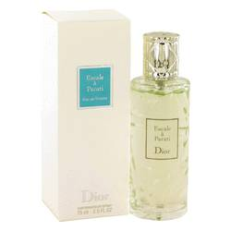

# *Escale A Parati*

***Description:***

Escale A Parati by Christian Dior Perfume. Escale A Parati starts with fresh notes of bitter orange, petitgrain and lemon. To round out and complement the citrus and nature-infused top notes, base notes of palisander rosewood, mint, cinnamon and red berries are introduced. The fragrance gets a bit more depth with base notes of woodsy notes and tonka bean. This is a light and airy fragrance for women who are looking for a simple scent that is perfect for work and daytime wear.  
  
Christian Dior is a luxury company producing an array of top of the line beauty products and fashions. This runway brand creates timeless fragrances with the help of in-house perfumer Francois Demachy. The upscale fragrances for women and men are meant to inspire the senses and perfectly complement the brand’s iconic fashions. The Escale A Parati bottle is tall and narrow with intricately sculpted glass. A sculpted silver cap tops off this luxurious bottle.